Topic 1: Login page using HTML, CSS, JS
1. Problem Statement
Develop a modern secure login page using HTML, CSS, and JavaScript that:
- Validates username and password
- Enforces strong password rules
- Provides interactive UI features
- Displays processed output (ASCII values)

2. Description
This project is a frontend-based login system with:
- Stylish UI using CSS (gradient + glass effect)
- Real-time validation
- Password visibility toggle
- ASCII conversion of user inputs
It focuses on user input validation and UI interaction.

3. Structure of the Project
LoginProject (JavaScript)
- Login.html
- Sections
- HTML (Form structure)
- CSS (Styling)
- JavaScript (Logic)
- Features
- Username validation
- Password validation
- Toggle password visibility
- ASCII conversion

4. Test Cases
Test Case |  | Input | Expected Output
Valid Input |  | user123 / Strong@123 | ASCII values displayed
Short Username |  | ab | Error message
Weak Password |  | abc123 | Validation error
Toggle Password |  | Click eye icon | Show/Hide password
Empty Fields |  | — | Required field warning

Login.html
<!DOCTYPE html>
<html lang="en">
<head>
<meta charset="UTF-8">
<title>Modern Login</title>
<style>
body {
font-family: 'Segoe UI', sans-serif;
background: linear-gradient(135deg, #667eea, #764ba2);
height: 100vh;
display: flex;
justify-content: center;
align-items: center;
margin: 0;
}
.login-container {
backdrop-filter: blur(15px);
background: rgba(255, 255, 255, 0.15);
border-radius: 15px;
padding: 35px;
width: 340px;
color: white;
box-shadow: 0 10px 30px rgba(0,0,0,0.3);
}
.login-container h2 {
text-align: center;
margin-bottom: 25px;
}
.input-group {
margin-bottom: 18px;
}
.input-group label {
font-size: 14px;
}
.input-group input {
width: 100%;
padding: 10px;
border-radius: 8px;
border: none;
outline: none;
margin-top: 5px;
}
.password-box {
position: relative;
}
.toggle {
position: absolute;
right: 10px;
top: 38px;
cursor: pointer;
font-size: 14px;
color: black;
}
.btn {
width: 100%;
padding: 12px;
background: #ff7eb3;
border: none;
border-radius: 8px;
color: white;
font-size: 16px;
cursor: pointer;
transition: 0.3s;
}
.btn:hover {
background: #ff4e8a;
transform: scale(1.05);
}
.output {
margin-top: 15px;
font-size: 13px;
background: rgba(255,255,255,0.2);
padding: 10px;
border-radius: 8px;
}
.error {
color: #ffb3b3;
font-size: 13px;
margin-top: 5px;
}
</style>
</head>
<body>
<div class="login-container">
<h2>🔐 Secure Login</h2>
<form onsubmit="handleLogin(event)">
<div class="input-group">
<label>Username</label>
<input type="text" id="username" placeholder="Enter username" required>
</div>
<div class="input-group password-box">
<label>Password</label>
<input type="password" id="password" placeholder="Enter password" required>
<span class="toggle" onclick="togglePassword()">👁</span>
</div>
<div class="error" id="error"></div>
<button type="submit" class="btn">Login</button>
</form>
<div class="output" id="output"></div>
</div>
<script>
function toASCII(str) {
let asciiValues = [];
for (let i = 0; i < str.length; i++) {
asciiValues.push(str.charCodeAt(i));
}
return asciiValues.join(" ");
}
// Strong password validation
function isValidPassword(password) {
let regex = /^(?=.*[a-z])(?=.*[A-Z])(?=.*\d)(?=.*[@$!%*?&]).{8,}$/;
return regex.test(password);
}
function togglePassword() {
let pass = document.getElementById("password");
pass.type = pass.type === "password" ? "text" : "password";
}
function handleLogin(event) {
event.preventDefault();
let username = document.getElementById("username").value;
let password = document.getElementById("password").value;
let error = document.getElementById("error");
error.textContent = "";
if (username.length < 3) {
error.textContent = "Username must be at least 3 characters";
return;
}
if (!isValidPassword(password)) {
error.textContent = "Password must contain uppercase, lowercase, number & special character (min 8 chars)";
return;
}
let userASCII = toASCII(username);
let passASCII = toASCII(password);
document.getElementById("output").innerHTML = `
<b>Username ASCII:</b> ${userASCII} <br>
<b>Password ASCII:</b> ${passASCII}
`;
}
</script>
</body>
</html>
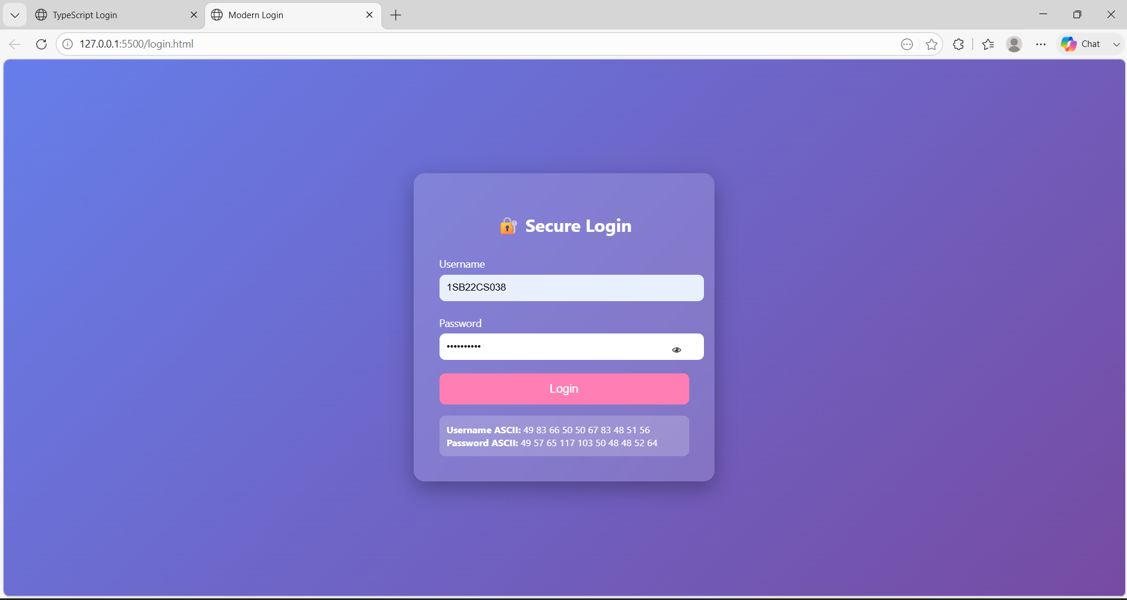
Topic 2: Login page using HTML and TS
1. Problem Statement
Develop a role-based login system using TypeScript that:
- Authenticates users
- Supports multiple roles (Admin/User)
- Applies encryption logic
- Redirects users based on roles

2. Description
This project simulates a backend-like authentication system using:
- TypeScript (compiled to JavaScript)
- Object-Oriented Programming (OOP)
- Role-based access control
It includes:
- User authentication
- Password encryption
- Role-based dashboard redirection

3. Structure of the Project
LoginProject (TypeScript)
- Index.html
- Loginrolebased.ts
- Components
- Role (Enum)
- User (Interface)
- AuthService
- DashboardService
- Features:
- Role-based login
- Dashboard redirection
- Authentication system

Index.html
<!DOCTYPE html>
<html lang="en">
<head>
<meta charset="UTF-8">
<title>Login</title>

<!-- Bootstrap (optional for styling) -->
<link href="https://cdn.jsdelivr.net/npm/bootstrap@5.3.0/dist/css/bootstrap.min.css" rel="stylesheet">
</head>
<body>

<div class="container d-flex justify-content-center align-items-center vh-100">
<div class="card p-4 shadow">
<h3 class="text-center">Login</h3>

<form onsubmit="event.preventDefault(); runApp();">
<input type="text" id="username" class="form-control mb-3" placeholder="Username" required>
<input type="password" id="password" class="form-control mb-3" placeholder="Password" required>

<button class="btn btn-primary w-100">Login</button>
</form>

<p class="text-center mt-3" id="output"></p>
</div>
</div>

<script src="loginrolebased.js"></script>
</body>
</html>
Loginrolebased.js
// Role Enum
enum Role {
Admin = "ADMIN",
User = "USER"
}

// User Interface
interface User {
username: string;
password: string;
role: Role;
}

// Auth Service
class AuthService {
private users: User[] = [
{ username: "admin", password: "12345", role: Role.Admin },
{ username: "user", password: "abcde", role: Role.User }
];

login(username: string, password: string): User | null {
const user = this.users.find(
u => u.username === username && u.password === password
);
return user || null;
}
}

// Dashboard Service
class DashboardService {
redirect(user: User): void {
const output = document.getElementById("output");

if (user.role === Role.Admin) {
output!.innerText += "\nRedirecting to Admin Dashboard...";
} else {
output!.innerText += "\nRedirecting to User Dashboard...";
}
}
}

// Objects
const authService = new AuthService();
const dashboardService = new DashboardService();

// Main Function
function runApp(): void {
const username = (document.getElementById("username") as HTMLInputElement).value;
const password = (document.getElementById("password") as HTMLInputElement).value;
const output = document.getElementById("output");

output!.innerText = "";

if (username === "" || password === "") {
output!.innerText = "Please enter username and password";
return;
}

const user = authService.login(username, password);

if (user) {
output!.innerText = `Login Successful: ${user.role}`;
dashboardService.redirect(user);
} else {
output!.innerText = "Invalid Credentials";
}
}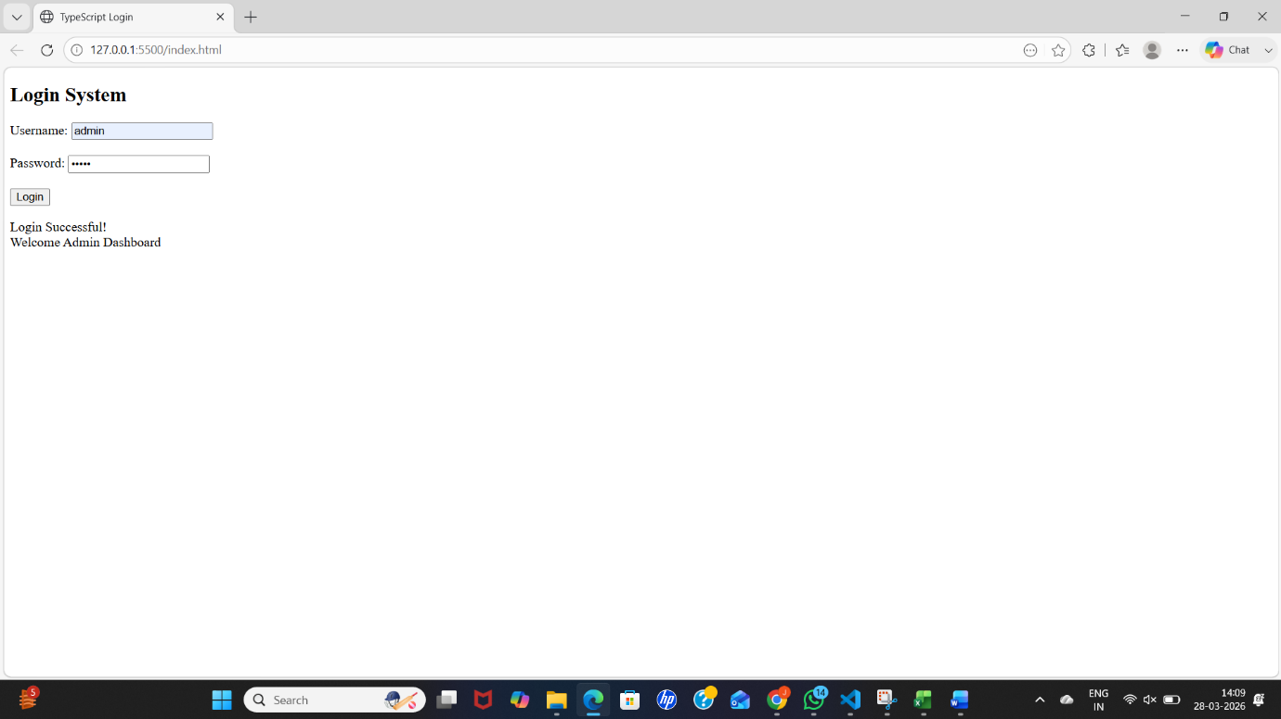
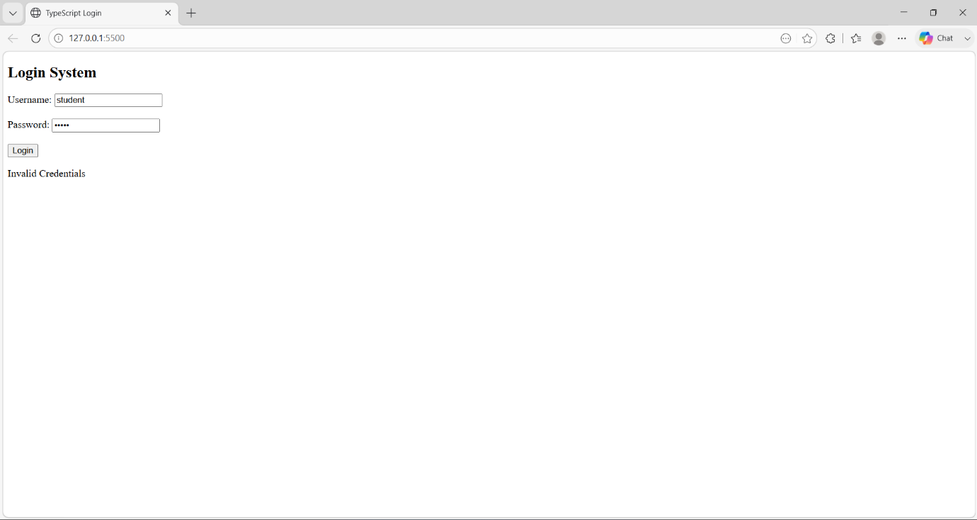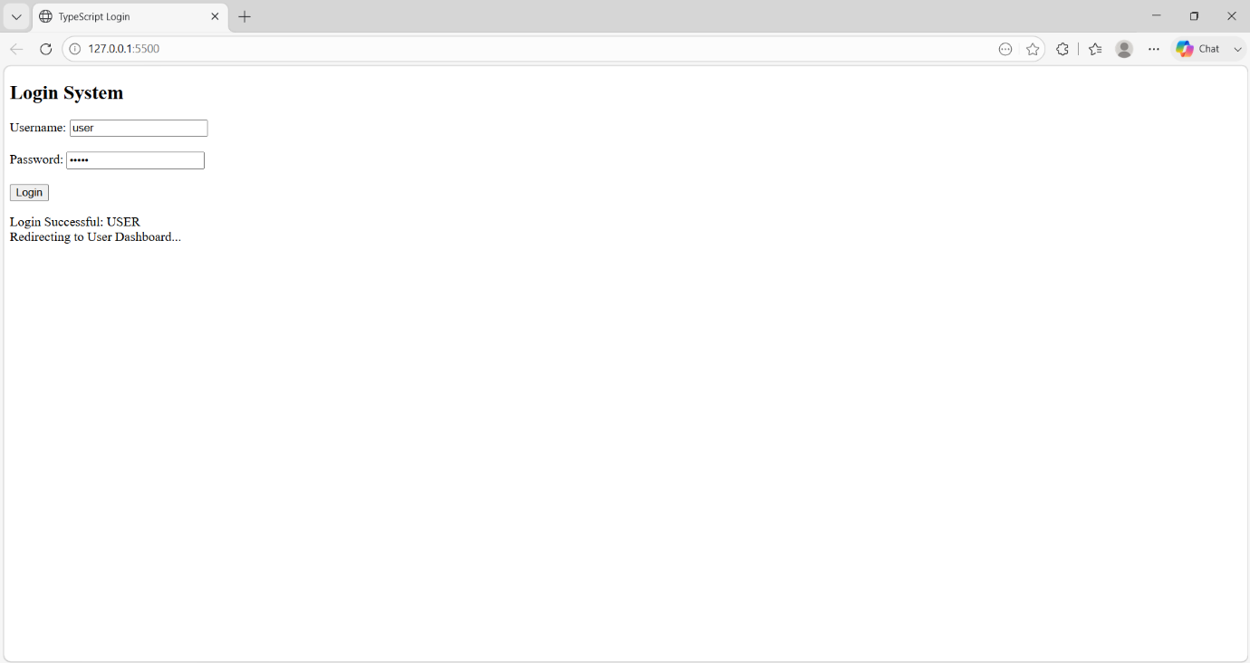

Topic 3: Login page using Angular
Step 1: Install Prerequisites
Make sure you have:
- Node.js (check using node -v)
- npm (comes with Node, check using npm -v)
👉 Download from: https://nodejs.org

Step 2: Install Angular CLI
Open terminal / command prompt and run:
npm install -g @angular/cli
Check installation:
ng version

Step 3: Create a New Angular Project
ng new my-first-app
- Press Enter for default settings
- Choose CSS when asked for stylesheet

Step 4: Move into Project Folder
cd my-first-app

Step 5: Run the Application
ng serve
Open browser and go to:
http://localhost:4200
You will see the Angular default page!

Step 6: Create a Simple Component
ng generate component hello
(or)
ng g c hello
